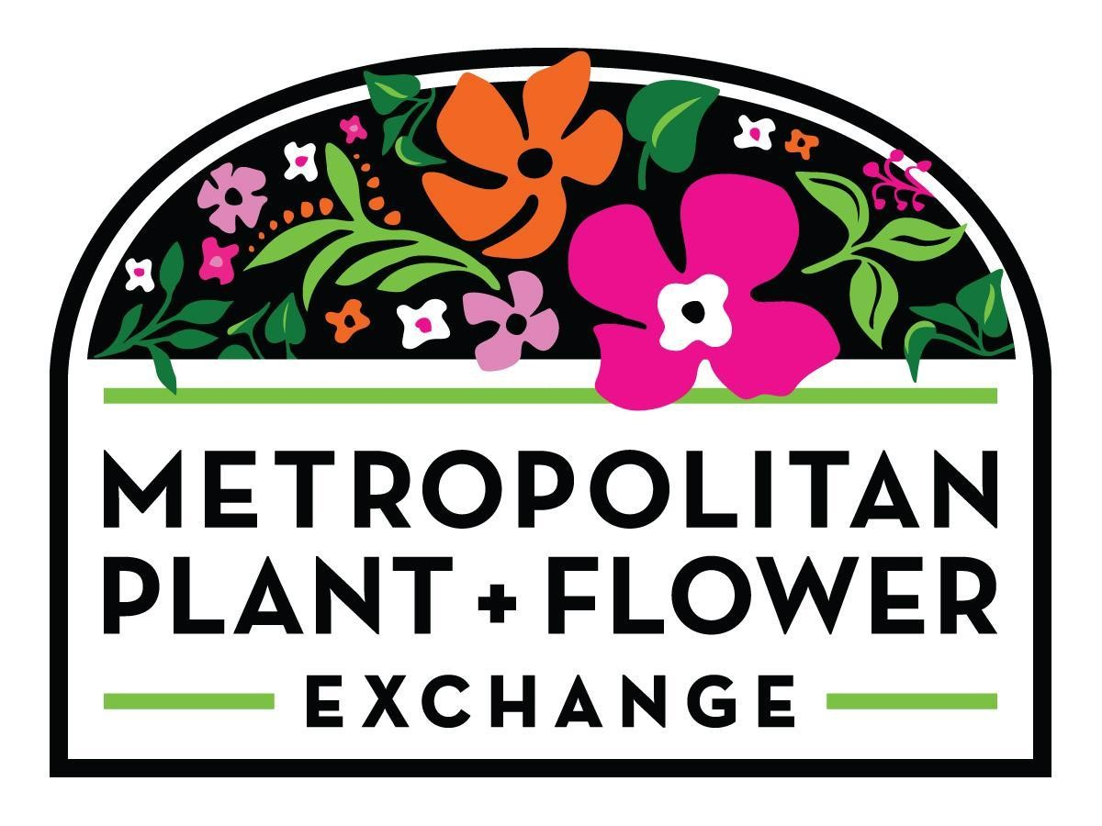
Make a purchase of $50 or more at
Metropolitan Plant & Flower Exchange or Metropolitan Farm,
and Metropolitan will donate $10 to

Saint Matthew Church

Complete Form Below & Present at Time of Purchase
Offer Expires 12/31/2025
*Cannot be combined with any other offers*

Name_________________________________________________________________________________________________________
Address______________________________________________________________________________________________________
________________________________________________________________________________________________________________
Email_________________________________________________________________________________________________________
(For Store Use) Order #____________________ Total $___________________ Date___________________________

FORT LEE PARAMUS WEST CALDWELL. CLOSTER
2125 Fletcher Ave. 840 Route 17 N. 246 Passaic Avenue 119 Hickory Lane
201-944-1050 201-445-7101 973-736-0049 201-767-0244

** All Locations Open 7 Days a Week **
www.metroplantexchange.com

